Divya Patel

IT340 User Assignment

1. Create a user (**sudo useradd --create-home --shell /bin/bash --user-group hwuser1**)
   1. Explain what **--create-home** does (more so than just “creates home directory”)
      1. **[create user in the home directory as default]**
   2. Explain what **--shell** does
      1. **[Provide interface with takes out input and display output based on the input]**
   3. Explain what **--user-group** does
      1. **[select group able to share files with each other]**
2. Review the following files using cat (do not open with nano / vi / etc as you may lock it by mistake)
   1. /etc/passwd
      1. What is this file?
         1. **[contains all the information of all user accounts]**
         2. **[]**
   2. /etc/shadow
      1. What is this file?
         1. **[used to store information about user authentication]**
         2. **[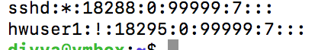]**
   3. /etc/group
      1. What is this file?
         1. **[defines the groups to which users belong under]**
         2. **[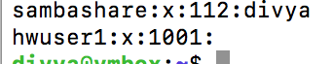]**
   4. /etc/gshadow
      1. What is this file?
         1. **[encrypted password used to access user information like group file]**
         2. **[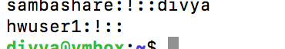]**
3. How do you check the manual of a command?
   1. **[using man command you display the manual of a command]**
4. Manually create a user (The following commands are safe ways to edit the previously mentioned files)
   1. Run **vipwd** and manually enter a new line for hwuser2
      1. **[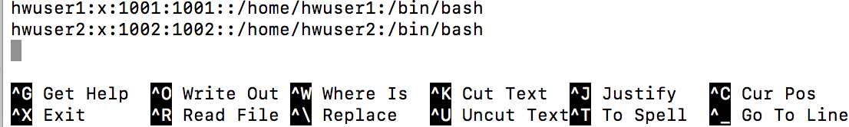]**
   2. Run **vipwd -s** and manually enter a new line for hwuser2
      1. **[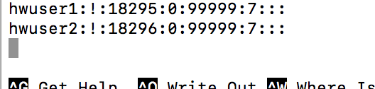]**
   3. Run **vigr** and manually enter a new line for the group of hwuser2
      1. **[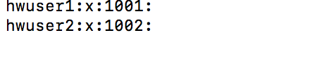]**
   4. Run **vigr -s** and manually enter a new line for the group of hwuser2
      1. **[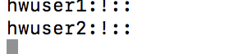]**
5. Create a password for the users
   1. **passwd hwuser1**

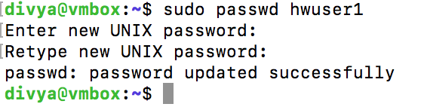

* 1. **passwd hwuser2**

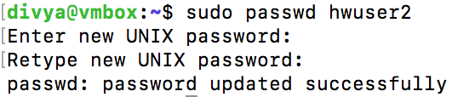

1. Switch to hwuser1 and inspect the directory structure/permissions/ownership of /home/hwuser1
   1. **su - hwuser1**
   2. **ls -al /home/hwuser1**
   3. Using the numerical form of permissions (i.e., 664, 775, 777) what is the default permissions applied to the new user’s home folder?
      1. **[807]**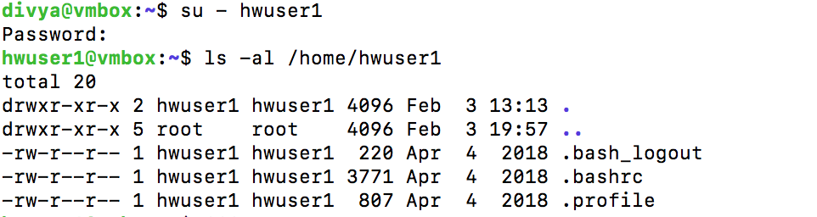
2. Switch back to your sudo user
   1. **su - vmusername**

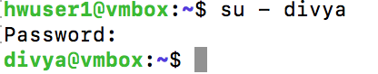

1. Check the home directory of hwuser2
   1. **ls /home/hwuser2**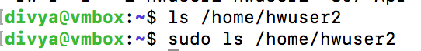
2. Create a home directory for hwuser2
   1. **mkdir /home/hwuser2**
3. Give hwuser2 ownership of the directory
   1. **chown hwuser2:hwuser2 /home/hwuser2**
   2. Verify changes
      1. **ls -al /home/hwuser2**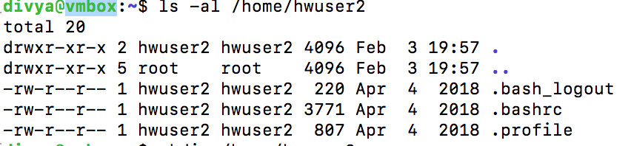
4. Give hwuser2 permissions for their home directory
   1. **chmod 775 /home/hwuser2**
   2. Verify changes
      1. **ls -al /home/hwuser2**
5. Show the ownership/permissions
   1. **[]**
6. Switch to hwuser2
   1. **su - hwuser2**
   2. You shouldn’t have any errors and pwd should show /home/hwuser2
   3. Try to run **sudo ls** (you shouldn’t be able to)
   4. Run **groups**
      1. **[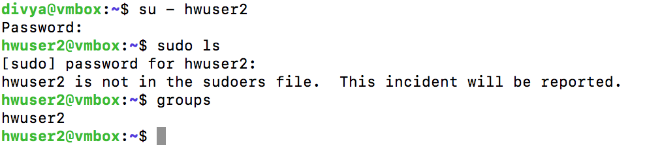]**
7. Add hwuser2 to sudoers
   1. **Switch back to sudo enabled account**

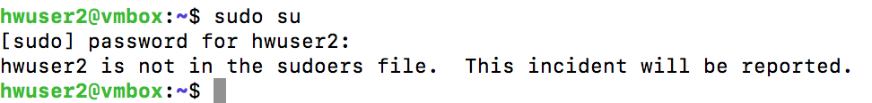

* 1. **usermod -aG sudo hwuser2**

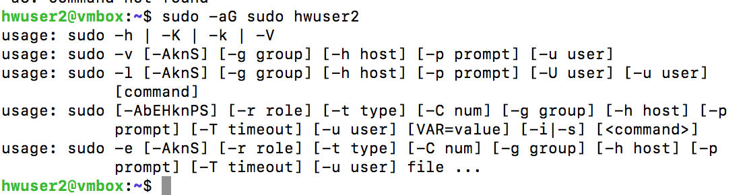

* 1. Check the groups



1. Run the following command
   1. **usermod -G sudo hwuser1**
   2. Show the groups of the user
      1. **groups hwuser1**
      2. **[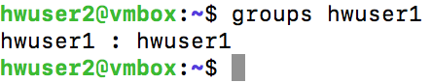]**
2. Show the commands necessary to fix the hwuser1 groups (they should not have “root” in the list)
   1. 